**SQL questions:**

Given “**Employee**” table below, please write the following  ***SQL statements*** :

**Employee**

|  |  |  |  |
| --- | --- | --- | --- |
| id | Name | salary | manager_id |
| 1 | John | 300 | 3 |
| 2 | Mike | 200 | 3 |
| 3 | Sally | 550 | 4 |
| 4 | Jane | 500 | 7 |
| 5 | Joe | 600 | 7 |
| 6 | Dan | 600 | 3 |
| 7 | Phil | 550 | NULL |
| … | … | … | … |

1. Give the names of employees, whose salaries are greater than their immediate managers’:

select distinct Name from Employee A Join Employee B on A.manager_id = B.id WHERE A.salary > B.salary

1. What is the average salary of employees who do not manage anyone? In the sample above, that would be John, Mike, Joe and Dan, since they do not have anyone reporting to them.

select avg（salary） from Employee where id not in （select distinct manager_id from employee where manager_id != NULL）

**q/KDB+ questions:**

**Employee query.**

Repeat the previous SQL query but write the KDB equivalent query

1.

select Name from (Employee lj ([manager_id:Employee`id] wage:Employee`salary)) where (not null manager_id) and (salary>wage)

2.

select avg salary from Employee where (not null manager_id) and (not id in Employee`manager_id)

**Exists?**

Write a function 'e' which takes a variable symbol v and returns 1b if v is defined and 0b if it is not:

a:10

exists`a

1b exists`b

0b

exists:{x in key `.}

**Dictionary to list.**

Write a function 'undict' which takes a nested dictionary and replaces each dictionary with a pair of lists: (symbols;values):

d:`a`b!(`c`d`e!10 20 30;`f`g!(40;`h`i`j!50 60 70))

undict d

(`a`b;((`c`d`e;10 20 30);(`f`g;(40;(`h`i`j;50 60 70)))))

undict : {:$[99h=type x;(key x;.z.s each value x);x]}

**Infinite loop.**Without using a loop or recursion, find an expression which causes an infinite loop.

{sqrt x}\[{x>0};100]

**Depends on me.**In q we define a view or "dependency" with '::', e.g.:

a:10

b::a+1

c::a+2

d:c+20

e::b+d

f::e+4

g::f+5

In this example, if a is reassigned, then b, c, e, f and g are invalidated. Referencing an invalid variable causes its definition to re-compute and return a new value. In general if any variable is invalidated, then all of its descendants are invalidated.

The primitive .z.b takes one or more symbols s and for each symbol k in s returns a vector of symbols of variables which *directly* depend on k:

q) .z.b`a`d

`b`c

,`e

Write a function 'dependson' which takes a single symbol v and returns a list of ALL the variables which are invalidated by assignment to v, e.g.:

q) dependson`a

`a`b`c`e`f`g

dependson:{if[doesExist x; .z.s each .z.b 0N! x;]}

**Who moved?**

You're given a vector of unique elements:

v:10 20 30 40 50 60 70

Some operation has moved a single one of the elements into a new position:

w:10 20 70 30 40 50 60 / 70 inserted between 10 and 20

There is a function which returns the index of the repositioned element:

moved[v;w]

2

moved[10 20 30;20 30 10]

2

moved[10 20;20 10]

0

Write 'moved'.

v:10 20 30 40 50 60 70

w:10 20 70 30 40 50 60

moved :{first where ((y?x) - (til count y))=1}

**Maximum Overlap Intervals.**

Given the following table:

procs:([]id:10*1+til 8;anest:`baker`baker,6#`dow;start:"t"$08:00 09:00 09:00 08:00 10:00 12:30 13:30 18:00;end:"t"$11:00 13:00 15:30 13:30 11:30 13:30 14:30 19:00)

1. Write a query to list out the ids each row is intersecting with. Append answer to the last column as w
2. Write a query to determine for each anest the max # intersecting ids over periods of intersection. Append answer as the last column as s

Expected outputs:

id anest start end s w

---------------------------------------------------

10 baker 08:00:00.000 11:00:00.000 2 10 20

20 baker 09:00:00.000 13:00:00.000 2 10 20

30 dow 09:00:00.000 15:30:00.000 3 30 40 50 60 70

40 dow 08:00:00.000 13:30:00.000 3 30 40 50 60

50 dow 10:00:00.000 11:30:00.000 3 30 40 50

60 dow 12:30:00.000 13:30:00.000 3 30 40 60

70 dow 13:30:00.000 14:30:00.000 2 30 70

80 dow 18:00:00.000 19:00:00.000 1 ,80

(i)

len: count procs;

procs: update

head:start>=(len,len)#end,

tail:end<=(len,len)#start,

class:anest=(len,len)#anest from procs;

procs: update w:(class * (head+tail)=0)=1 from procs;

procs: update w:id @[w;::;where] from procs;

procs: select id,anest,start,end,w from procs;

(ii)

anestList: distinct procs`anest;

sList: ();

iAnest: 0;

while[iAnest<count anestList;

target: anestList[iAnest];

tb: select from procs where anest=target;

timeList: tb`start;

timeList,: tb`end;

len: -1 + count timeList;

tb: update head: start<=((count tb),len)#(timeList til len) from tb;

tb: update tail: end>=((count tb),len)#(1+timeList til len) from tb;

tb: update contained: head*tail from tb;

tb: update overlap: contained*((count tb),len)#(sum contained) from tb;

tb: update s: @[overlap;::;max] from tb;

sList,: tb`s;

iAnest: iAnest+1];

procs: update s:sList from procs;

**Average price computation.**

Write a query to compute avgprc for trades in the attached file avgprc.csv.

The correct answer is the avgprc col of this file.

The format for avgprc.csv is:

("SFFF";enlist",")0:`:avgprc

The spec of avgprc is:

avgprc starts with the first prc where tran=`open.

it is calculated thus: when you are increasing your position (long or short) the formula is:

((avgprc*abs prev accumulated)+prc*abs trd)%abs accumulated

it does not change until you switch sides; i.e accumulated trd switches sign at which point it resets to prc.

**Pascal Triangle**

Create a function to compute N layer of pascal triangle.

Example for 10/11? layers:

q)pascal[10]

1

1 1

1 2 1

1 3 3 1

1 4 6 4 1

1 5 10 10 5 1

1 6 15 20 15 6 1

1 7 21 35 35 21 7 1

1 8 28 56 70 56 28 8 1

1 9 36 84 126 126 84 36 9 1

1 10 45 120 210 252 210 120 45 10 1

pascal:{{prior[+]x,0}\[x-1;1]}

**R questions:**

**Maximum Overlap Intervals.**

Repeat the q/KDB+ question in previous section and implement in R language instead. Table is given below as R’s data.frame. Allow to use data.table, dplyr, xts, zoo package(s) or any preferred libraries at your discretion to complete the task.

R> data.frame(id=seq(10,80,by=10),anest=c("baker","baker",rep("dow",6)), start=c("08:00","09:00","09:00","08:00","10:00","12:30","13:30","18:00"),end=c("11:00","13:00","15:30","13:30","11:30","13:30","14:30","19:00"))

id anest start end

1 10 baker 08:00 11:00

2 20 baker 09:00 13:00

3 30 dow 09:00 15:30

4 40 dow 08:00 13:30

5 50 dow 10:00 11:30

6 60 dow 12:30 13:30

7 70 dow 13:30 14:30

8 80 dow 18:00 19:00

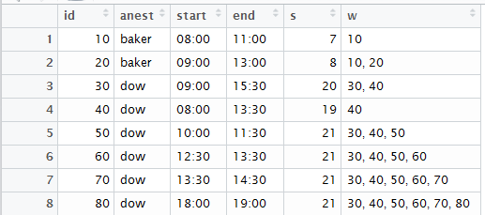

**Pascal Triangle**

Repeat the q/KDB+ question in previous section and implement in R language instead.

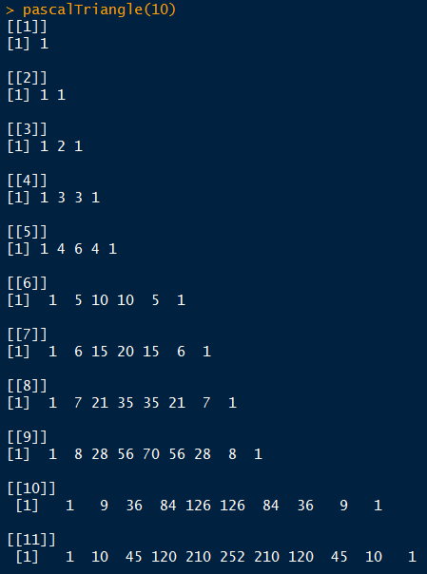

**Portfolio VaR & CVaR**

Assume you have the following portfolio as of 2016/01/01:

AAPL.O 15%

IBM.N 20%

GOOG.O 20%

BP.N 15%

XOM.N 10%

COST.O 15%

GS.N 05%

1. Using historical daily returns (Yahoo/Google Finance or any other market data source), calculate VaR95% and CVaR95% of the portfolio as of 2016/12/31

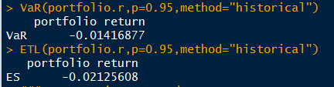

1. Using expected mean, covariance matrix and parametric method, calculate VaR95% and CVaR95%.

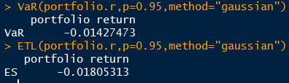

1. Assume you can change weights, allow shorting but no leverage (i.e. sum of weights equal to 100%), and rebalance monthly. What is the optimal portfolio holding by end of each month, till end of 2016

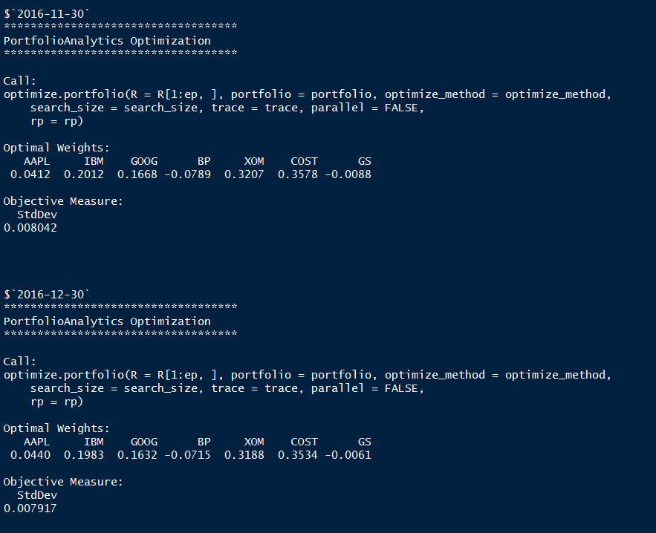

* Notes: Please state your assumption(s), if any

**Position calculator**

Refer to the data file, “pos.csv”, “trd.csv”:

1. From “pos.csv”, calculate the netted position per each user

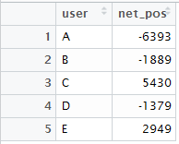

1. List out all the boxed positions.

Boxed positions are defined as:

A trader has long (quantity > 0) and short (quantity < 0) positions for the same symbol at different brokers (pb)

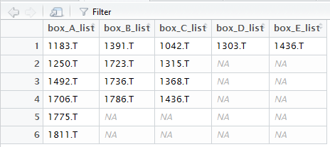

1. From the “trd.csv”, assume all the orders arrived at the same time, find all the potential crossing. Create a file with the original quantity (qty), journal (jrnl) and trades (trd)columns

e.g

sym user qty jrnl trd

1310.T A -146 146 0

1310.T B 1990 43 1947

1310.T C 1889 41 1848

1003.T A 816 0 816

1003.T C 2411 0 2411

1003.T D 2880 0 2880

(the “?” is where you need to calculate and fill out)

1. From output in (iii.), find the total quantity to trade, group by sym

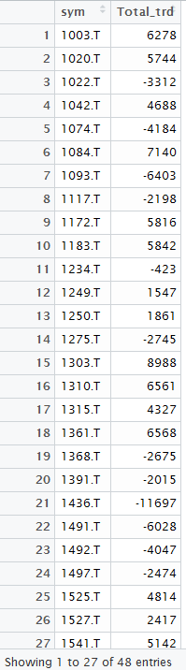

1. Using “pos.csv” and “trd.csv”, find the final position, per user, per sym. (assume all trades in trd.csv got fully executed; and the boxed positions all collapsed to the largest holding account)

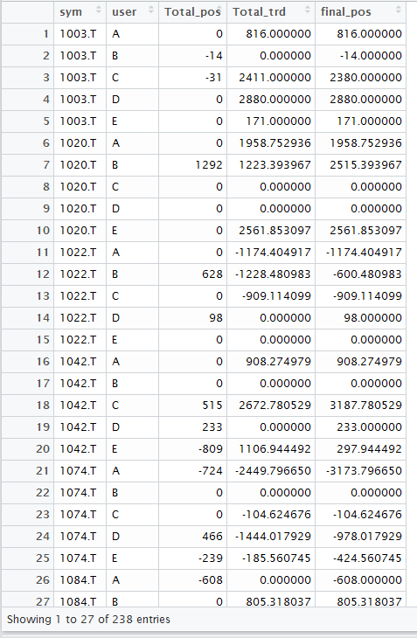

1. Create a Unit test to check your calculation for the above questions. Think about what conditions should be check and passed or else should raise errors, etc.

### Q6 The question description is very vague, and we could check the solution quality from serveral perspective: First is the data quality, we should cross check our data from mutli-sources. Second is the defination, we should check the definition of journal and trades, and compare our theoretical result with the market data. Third, we shoul loose our assumption and make our analysis close to the practice. For example, we cannot assume that all the orders arrive at the same time.